Eduacation Plan

By

Ranjit Singh

Final Project

# 

# Project Proposal

## Goals and Objectives

The main goal of the project is to implement an online web application named “ZOVI Fashion”. The main purpose of the application is help people to find best suitable garments from variety of brands and studio entries of latest trends. In this application there are two types of users- admin and registereduser. Admin has different functionalities as compare to registered user. Admin can insert, edit, delete and check details of all studio stuff,products and their brands. Admin can edit, delete and check details of the product reviews. Also, admin can delete and access details of the reviews and brands.

## Project Scope

The scope of this project is to implement an app named “Education Plan” with the help of which user can find some clothing and review them. The duration of the project is 20 working days which is equals to 4 weeks.

## Project Specifications

* Admin login/logout
* Add, edit, delete and check details of product by admin.
* Admin can delete, edit and check Students, courses and Queries

## Target Audience

The target audience for this project is the Education Partners who can store their data in this project for keeping the record of the Institution.

## Project Deliverables

The deliverables of the project are as follows:

|  |  |
| --- | --- |
| Deliverable | Description |
| Final Report | This will be the final report of the project. |
| Coding | The executable code of the project will go under this. |
| Documentation | This portrays the documentation of the project. |

## Resource Requirements

* Windows Operating System.
* Microsoft word for documentation.
* Asp.net MVC Framework
* 64-bit Processor and 8 GB or more RAM
* Identity framework- ASP

## Project Tasks and Milestones

|  |  |  |  |  |
| --- | --- | --- | --- | --- |
| **Tasks** | **Week-1** | **Week-2** | **Week-3** | **Week-4** |
| Brainstorming and analysis |  |  |  |  |
| Planning and initial meeting Project Proposal document. |  |  |  |  |
| Database Design and UI Design |  |  |  |  |
| Identity framework implementation |  |  |  |  |
| Coding for admin and reporter |  |  |  |  |
| Testing |  |  |  |  |
| Final Documentation and closing |  |  |  |  |

## Project Assumptions

Following are the assumption made while implementing the project:

* One admin can login and view courses and add and edit
* Application will be free and open source.

# Project Report

## Detail Design

### Home Page

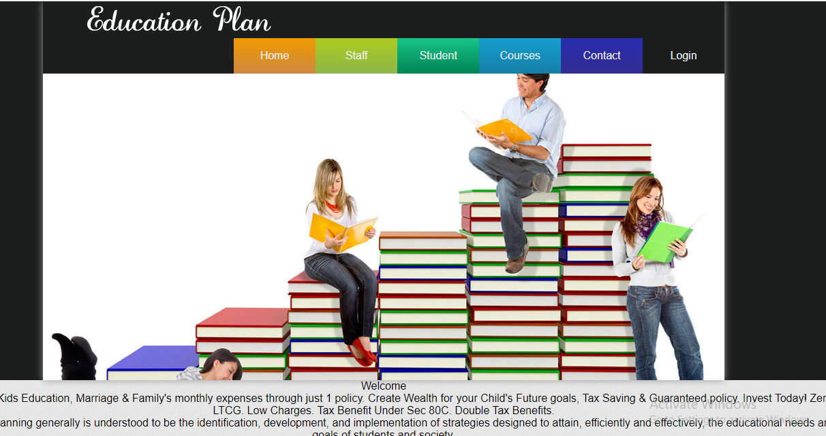

### Login Page

With the help of this page, Admin can Login enter details

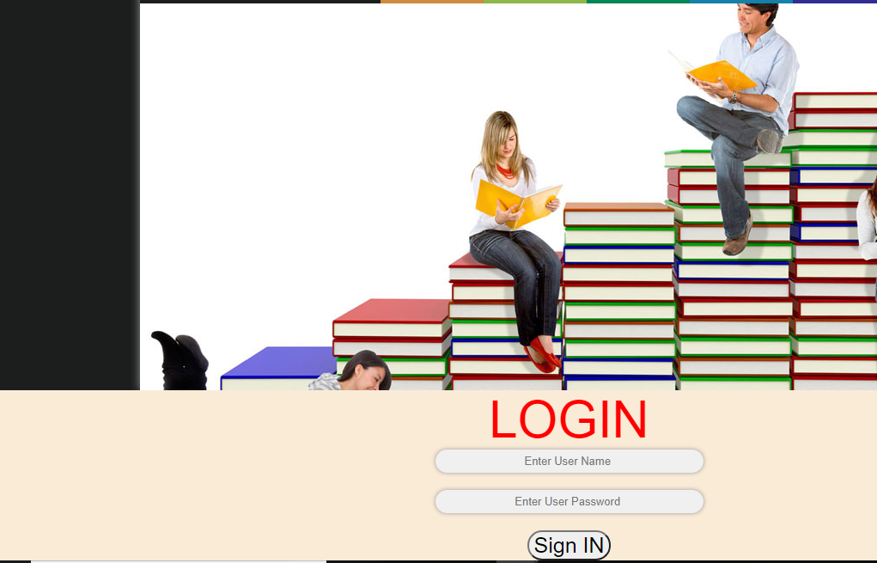

### Working Area

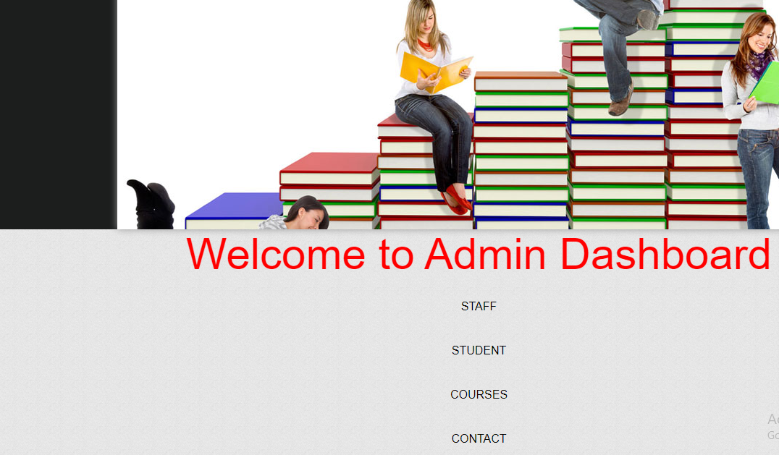

### Staff Page Admin View

With the help of this page admin can manage the staff by editing, deleting and checking their details.

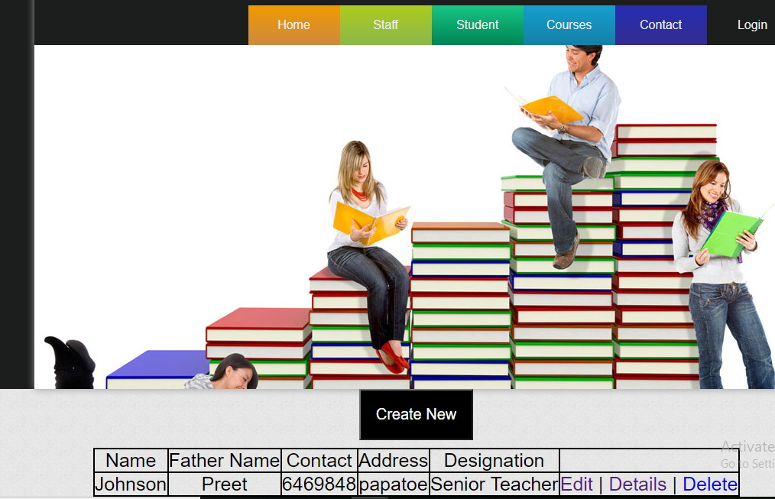

### Staff Page View

With the help of this page Visitor can view Staff details.

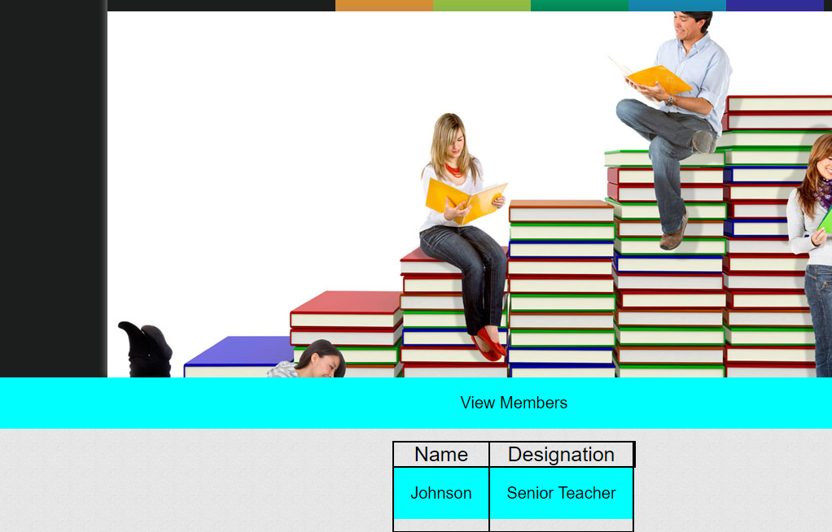

### Student Page View

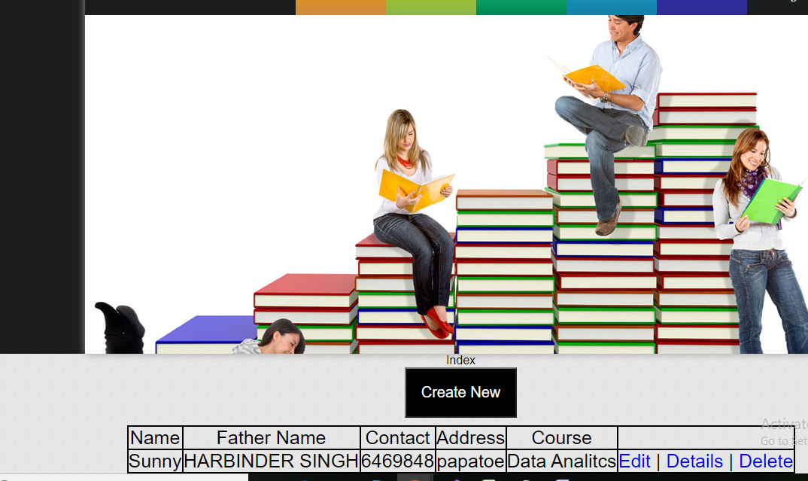

### Contact Page Query Details



# User Manual

The main purpose of the application Education Plan is to add data of students, staff . Admin has different functionalities as compare to customers. Admin can add, edit, delete and check details of staff, course entries.

## Summary

### System Configuration

This app will be useful to for distributing product information in presentable format.

### User Access Levels

Only registered admins can access the features of this application.

* **Admin:**Admin has full access of the app can register new admins.